**Project report**

**IoT based Soil Moisture Monitoring System using ARDUINO**

**Introduction**

Optimal and effective use of water in coastal areas is an essential aspect of plant growth in horticulture and the maintenance of water availability. It is necessary to monitor soil moisture continuously as the basis for watering time. However, it is hard for farmers to be in the field frequently to monitor the land humidity, even using an instrument to measure it at the site. It is needed a monitoring technique that can control the land humidity remotely. This paper presents a design of wireless soil moisture measurement based on the Internet of Things. We applied capacitive soil moisture sensors coupled with an ESP32 WIFI with a built-in 12-bit ADC function for reading analog sensor output and establishing a wireless connection to the internet network. The ESP32 was programmed using Arduino software. We made a web-based user interface and Google spreadsheet application using the Nodered which is a programmable IoT platform to show soil moisture and control the irrigation sprayers through the pump. Soil moisture is basically the content of water present in the soil. This can be measured using a soil moisture sensor which consists of two conducting probes that act as a probe. It can measure the moisture content in the soil based on the change in resistance between the two conducting plates. The resistance between the two conducting plates varies in an inverse manner with the amount of moisture present in the soil. For more information about soil moisture sensor and how to use it, refer the topic [Soil Moisture Sensor](http://www.electronicwings.com/sensors-modules/soil-moisture-sensor) in the sensors and modules section.

**Code :**

 // Define the pins

 sensorPin = A0; // Soil moisture sensor connected to analog pin A0

int ledPin = 7;      // LED connected to digital pin 7

// Variables to store sensor value

int sensorValue = 0;

void setup() {

  // Initialize serial communication at 9600 baud rate

  Serial.begin(9600);

  // Initialize the LED pin as an output

  pinMode(ledPin, OUTPUT);

}int

void loop() {

  // Read the analog value from the sensor (0 to 1023)

  sensorValue = analogRead(sensorPin);

  // Print the sensor value to the Serial Monitor

  Serial.print("Soil Moisture Value: ");

  Serial.println(sensorValue);

  // Check if the soil is dry (Assume dry if value is below a certain threshold)

  if (sensorValue > 500) {  // Adjust this value based on your sensor calibration

    // Soil is dry, turn the LED on

    digitalWrite(ledPin, HIGH);

  } else {

    // Soil is wet, turn the LED off

    digitalWrite(ledPin, LOW);

  }

  // Wait for a second before taking another reading

  delay(1000);

}

**Circuit Diagram**

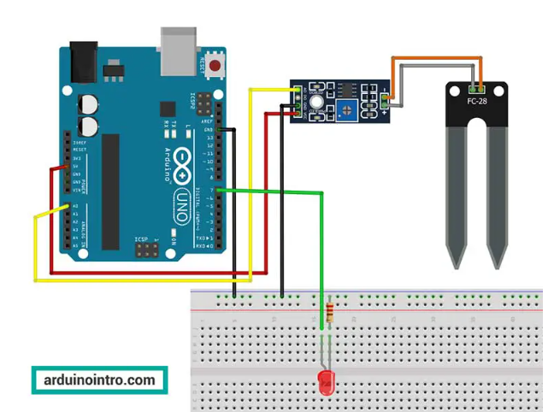

**Applications and Use Cases :**

Soil Monitoring with IoT uses technology to empower farmers and producers to maximise yield, reduce disease and optimise resources. IoT sensors can measure soil temperature, NPK, volumetric water content, photosynthetic radiation, soil water potential and soil oxygen levels. Data from the IoT sensors are then transmitted back to a central point (or the cloud) for analysis, visualisation and trend analysis. The resultant data can then be used to optimise farming operations, identify trends and make subtle adjustments to conditions to maximise crop yield and quality. The use of IoT in agriculture is known as Smart Agriculture (or Smart Farming), and IoT is a central component of Precision Farming. Soil temperature is an essential factor in belowground plant activity, influencing root growth, respiration, decomposition and [mineralisation of nitrogen](https://www.sciencedirect.com/topics/agricultural-and-biological-sciences/nitrogen-mineralization). IoT sensors can estimate soil temperature by measuring air temperature and other factors; however, the most accurate measurement is to use a probe buried in the soil. Depending on the root structure of the plant in question, multiple probes can be installed at different depths. Surface soil temperature can be monitored using a different type of IoT sensor that uses IR technology.

Soil temperature.

Non-Contact surface temperature. The moisture content of soil can also be monitored using buried probes with electrodes. In hydrology, soil science and agricultural moisture content play a vital role in soil chemistry, plant growth and groundwater recharge. Soil moisture content is essential for several reasons: Water in the soil serves as a critical nutrient for all crops and plants. Water is an essential component of photosynthesis. Crop yield is heavily influenced by the availability of water in the soil. Soil water is an important carrier of soluble food nutrients for plant growth. Soil water helps regulate soil temperatures. Rainfall/precipitation, wind, humidity and atmospheric pressure all play an essential role in plant growth. Our Smart Agriculture systems support several advanced weather stations.